**Configure replication in an Azure SQL Database managed instance database**

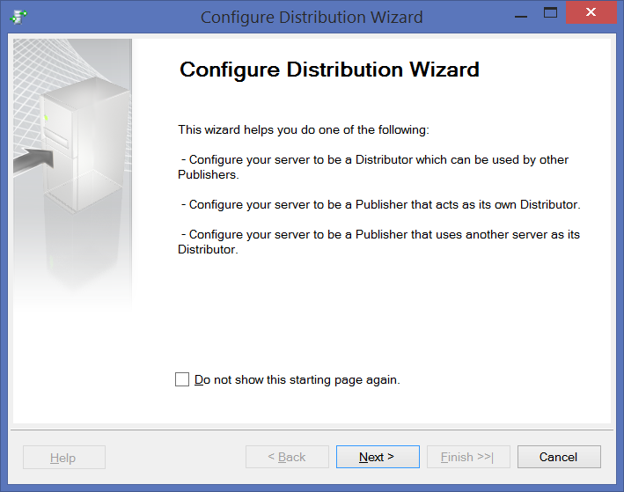

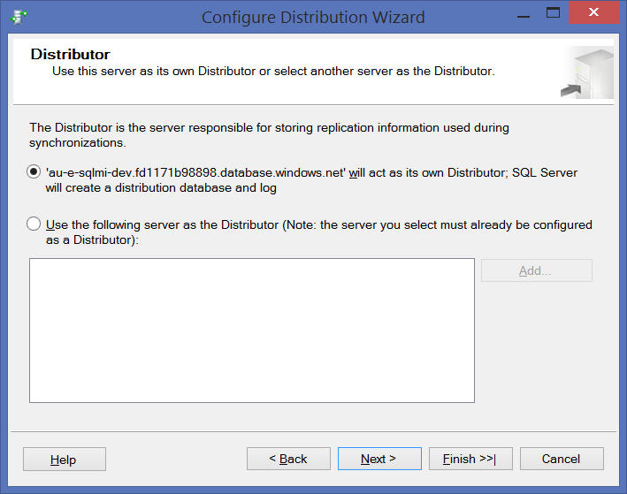

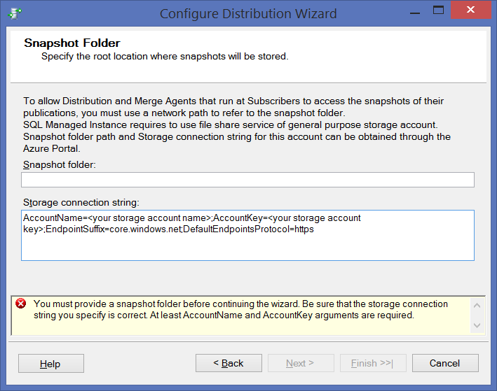

Fill the necessary info.

***Be sure that the path you specify is correct. The wizard cannot validate it because the accounts used to access the folder are not yet known.***

\\sqlmiodspoc.file.core.windows.net\sqlmipoc1

AccountName=sqlmiodspoc;AccountKey=TDAzx28MLDwcyZmS9VgejX0QFgTIKpBYn1aNtNjMwD1DtithIS2A3UPrl0pb6ydWtR/1rhhM2KKlV/PH3DbLtQ==;EndpointSuffix=core.windows.net;DefaultEndpointsProtocol=https

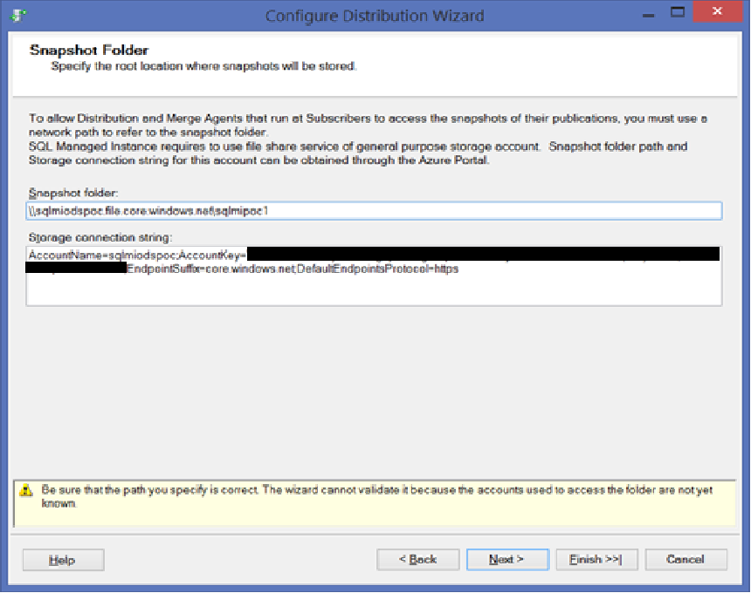

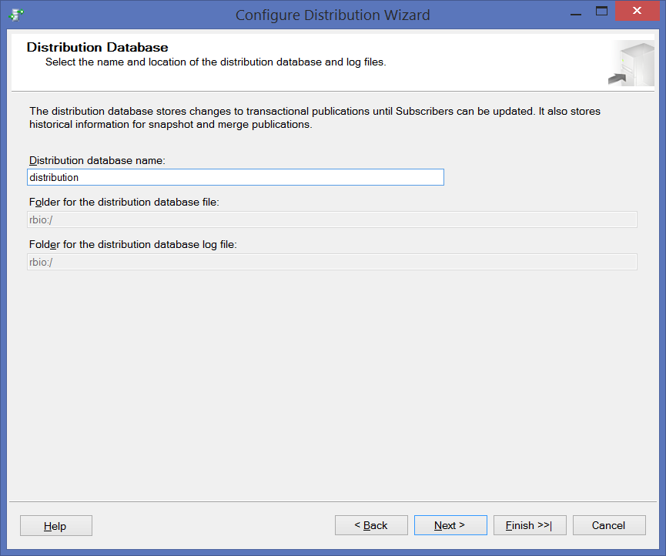

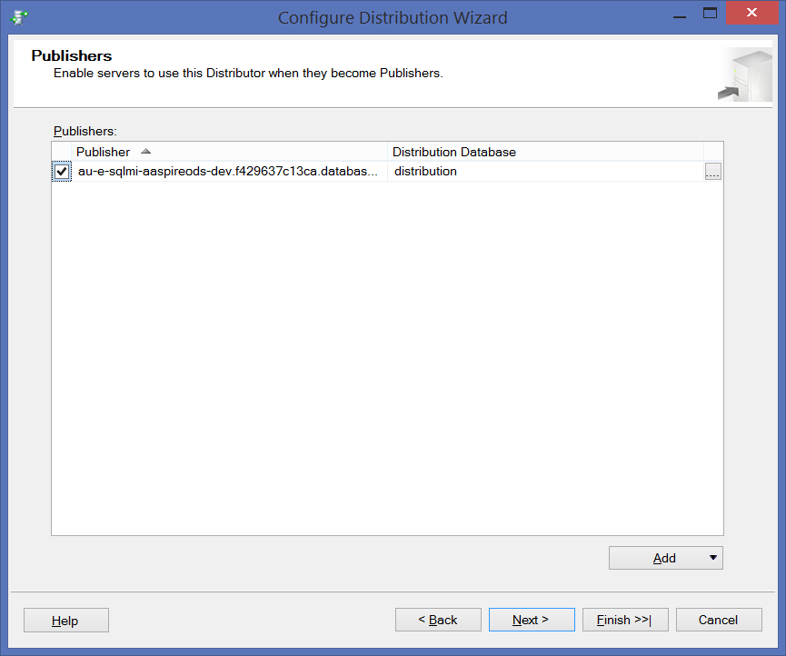

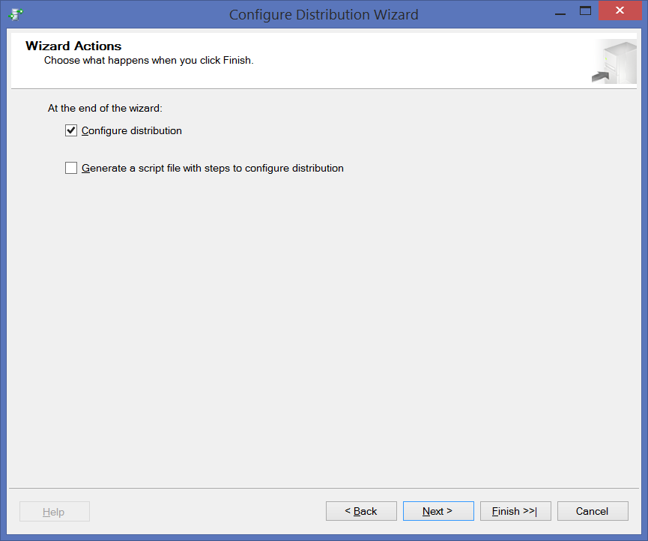

On Azure Portal, create a file share in a storage account, & get its properties

<https://sqlmiodspoc.file.core.windows.net/sqlmipoc1>

\\sqlmiodspoc.file.core.windows.net\sqlmipoc1

Copy the file share path in the format of: \\storage-account-name.file.core.windows.net\file-share-name

Copy the storage access keys in the format of: DefaultEndpointsProtocol=https;AccountName=<Storage-Account-Name>;AccountKey=****;EndpointSuffix=core.windows.net

e.g.

DefaultEndpointsProtocol=https;AccountName=sqlmiodspoc.file.core.windows.net;AccountKey=TDAzx28MLDwcyZmS9VgejX0QFgTIKpBYn1aNtNjMwD1DtithIS2A3UPrl0pb6ydWtR/1rhhM2KKlV/PH3DbLtQ==;EndpointSuffix=core.windows.net

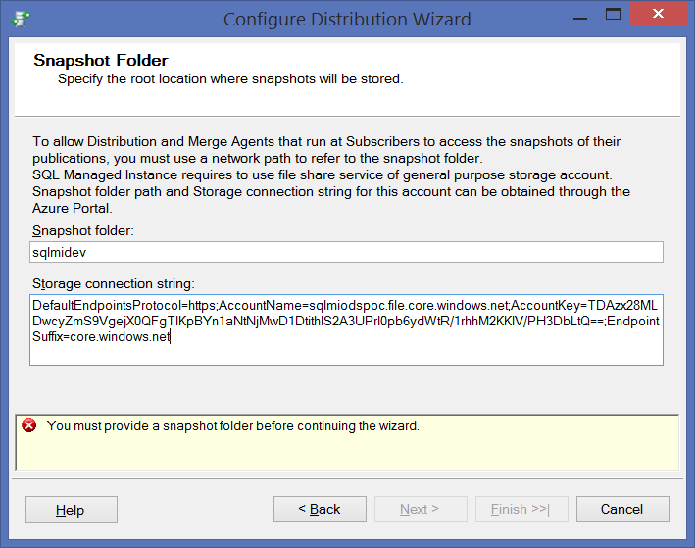

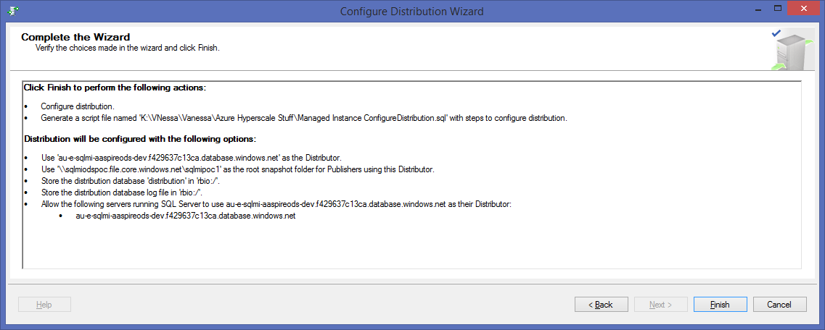

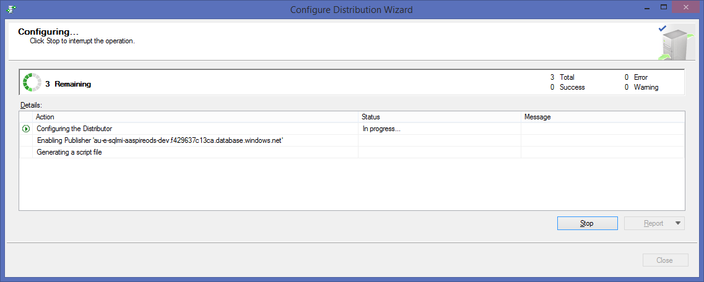

**ERROR:**

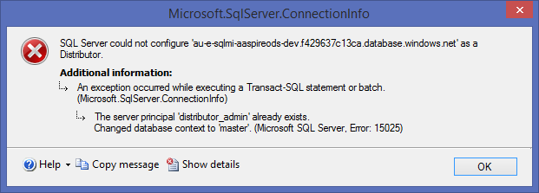

**RESOLUTION** : DROP the distributor_admin login & restart the wizard

**ERROR 2**

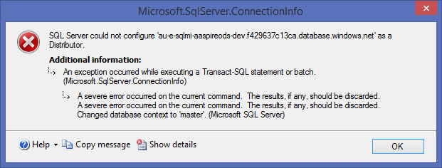

**Cannot go further so trying via command**

Step 1:-

EXEC sp_adddistributor @distributor = @@ServerName;

EXEC sp_adddistributiondb @database = N'ODSaaspirePRODC3';

GO

Step2: Run below in sqlsmd mode

:setvar username SQLAdmin

:setvar password KR42dM:85!`M)dd!

:setvar file_storage "\\sqlmiodspoc.file.core.windows.net\sqlmipoc1"

:setvar file_storage_key "DefaultEndpointsProtocol=https;AccountName=sqlmiodspoc.file.core.windows.net;AccountKey=TDAzx28MLDwcyZmS9VgejX0QFgTIKpBYn1aNtNjMwD1DtithIS2A3UPrl0pb6ydWtR/1rhhM2KKlV/PH3DbLtQ==;EndpointSuffix=core.windows.net"

USE [master]

EXEC sp_adddistpublisher

@publisher = @@ServerName,

@distribution_db = N'distribution',

@security_mode = 0,

@login = N'$(username)',

@password = N'$(password)',

@working_directory = N'$(file_storage)',

@storage_connection_string = N'$(file_storage_key)'; -- Remove this parameter for on-premises publishers

**ERROR**

Msg 21037, Level 16, State 1, Procedure sys.sp_MSrepl_adddistpublisher, Line 365 [Batch Start Line 1]

Invalid working directory 'sqlmiodspoc.file.core.windows.net\sqlmidev'.

**RESOLUTION**

Need to make sure you use **\\**sqlmiodspoc.file.core.windows.net\sqlmidev with the \\

**Step3:** Run below in sqlsmd mode. to enable replication for your database, and configure replication between your publisher, distributor, and subscriber

For example

:setvar username SQLAdmin

:setvar password KR42dM:85!`M)dd!

:setvar source_db ODSaaspirePRODB2

:setvar publication_name PublishData

:setvar object PLA011

:setvar schema dbo

:setvar target_server "sqlmiodspoc.file.core.windows.net"

:setvar target_username SQLAdmin

:setvar target_password KR42dM:85!`M)dd!

:setvar target_db Config

-- Enable replication for your source database

USE [$(source_db)]

EXEC sp_replicationdboption

@dbname = N'$(source_db)',

@optname = N'publish',

@value = N'true';

-- Create your publication

EXEC sp_addpublication

@publication = N'$(publication_name)',

@status = N'active';

EXEC sp_changedbowner 'SQLAdmin'

GO

EXEC sp_addarticle

@publication = N'$(publication_name)',

@type = N'logbased',

@article = N'$(object)',

@source_object = N'$(object)',

@source_owner = N'$(schema)'​;

ERROR

Msg 14088, Level 16, State 1, Procedure sys.sp_MSrepl_addarticle, Line 1556 [Batch Start Line 33]

The table '[dbo].[ctlPlan]' must have a primary key to be published using the transaction-based method.

RESOLUTION

Use only tables with Primary keys or add primary key to tables u need.

**CDC ERRORS**

Error:-

Msg 313, Level 16, State 3, Line 4

An insufficient number of arguments were supplied for the procedure or function cdc.fn_cdc_get_net_changes_

Explanation:-

This error message is somewhat misleading and basically hints that some parameters might be out of bound. The message is not further customized because of the limitation of table functions.

The zero value (0x00000000000000000000) is not a valid one. The sys.fn_cdc_get_min_lsn() returns this value if it cannot find the appropriate **capture instance name**. This name might deviate from the actual table name

The error can also occur if CDC was Enabled/Disabled multiple times at table level and created two capture instance for same table. I fixed this by disabling CDC at database level and then enabled all tables again, then it works fine.